Enrollment no.-9919103057

Name -Shubham Garg

Batch-F2

Q1

#include<stdio.h>

int main()

{

int i,n,p;

printf("enter the number of elements in the array");

scanf("%d",&n);

int array1[n];

for(i=0;i<n;i++)

{

printf("enter the element");

scanf("%d",&array1[i]);

}

printf("enter the number of elements you want to read");

scanf("%d",&p);

int array2[p];

for(i=0;i<p;i++)

{

array2[i]=array1[p-i-1];

}

for(i=0;i<p;i++)

{

printf("%d ",array2[i]);

}

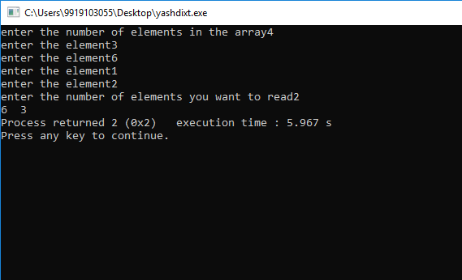

Q2

#include<stdio.h>

int main()

{

int i,n;

float sum;

sum=0;

sum=0;

printf("enter the number of elements in the array");

scanf("%d",&n);

int array[n];

for(i=0;i<n;i++)

{

printf("enter the element");

scanf("%d",&array[i]);

sum=sum+array[i];

}

printf("The sum of the elements of the array is %f",sum/n);

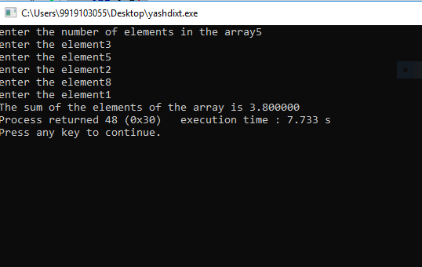

Q3

#include<stdio.h>

int main()

{

int i,n,count,sum,j;

sum=0;

count=0;

printf("enter the number of elements in the array");

scanf("%d",&n);

int array[n];

for(i=0;i<n;i++)

{

printf("enter the element");

scanf("%d",&array[i]);

}

for(i=0;i<n;i++)

{

for(j=i+1;j<n;j++)

{

if(array[i]==array[j])

{

count =count+1;

}

}

if(count>=1)

{

sum=sum+1;

}

count=0;

}

printf("The total number of duplicate items in the array are %d",sum);

}

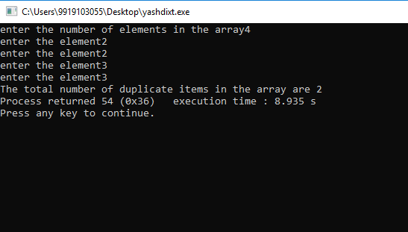

Q4

#include <stdio.h>

int main()

{

int arr[100], freq[100];

int size, i, j, count;

printf("Enter size of array: ");

scanf("%d", &size);

printf("Enter elements in array: ");

for(i=0; i<size; i++)

{

scanf("%d", &arr[i]);

freq[i] = -1;

}

for(i=0; i<size; i++)

{

count = 1;

for(j=i+1; j<size; j++)

{

if(arr[i]==arr[j])

{

count=count+1;

freq[j] = 0;

}

}

if(freq[i] != 0)

{

freq[i] = count;

}

}

printf("\nFrequency of all elements of array : \n");

for(i=0; i<size; i++)

{

if(freq[i] != 0)

{

printf("%d occurs %d times\n", arr[i], freq[i]);

}

}

return 0;

}

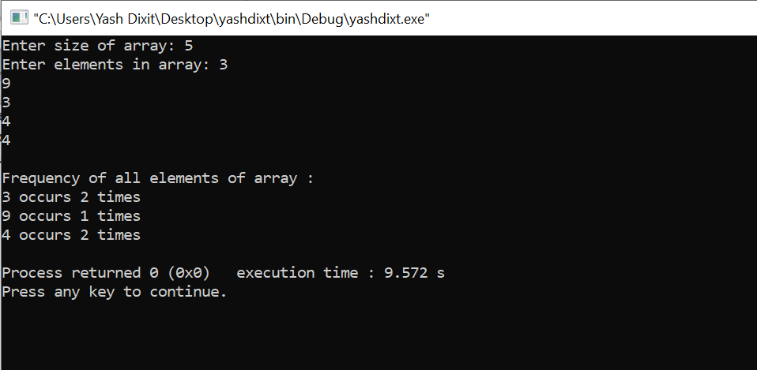

Q5

#include<stdio.h>

int main()

{

int i,n,count,sum,j;

sum=0;

count=0;

printf("enter the number of elements in the array");

scanf("%d",&n);

int array[n];

for(i=0;i<n;i++)

{

printf("enter the element");

scanf("%d",&array[i]);

}

int min ,max;

max=array[0];

for(i=0;i<n;i++)

{

if(array[i]>max)

{

max=array[i];

}

}

printf("The max value is %d",max);

printf("\n");

min=array[0];

for(i=0;i<n;i++)

{

if(array[i]<min)

{

min=array[i];

}

}

printf("The min value is %d",min);

}

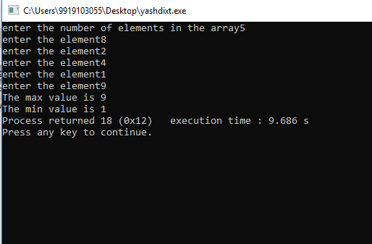

Q6

#include <stdio.h>

#include <stdlib.h>

int main()

{

int n,i,count1,count2;

count1=0;

count2=0;

printf("Enter the number of elements in the array");

scanf("%d",&n);

int array[n];

for(i=0;i<n;i++)

{

printf("enter the element");

scanf("%d",&array[i]);

}

int array1[n],array2[n];

for(i=0;i<n;i++)

{

if(array[i]%2==0)

{

array1[count1]=array[i];

count1=count1+1;

}

else

{

array2[count2]=array[i];

count2=count2+1;

}

}

printf("The array of even numbers is :\n");

for(i=0;i<count1;i++)

{

printf("%d ",array1[i]);

}

printf("\n");

printf("The array of odd numbers is :\n");

for(i=0;i<count2;i++)

{

printf("%d ",array2[i]);

}

}

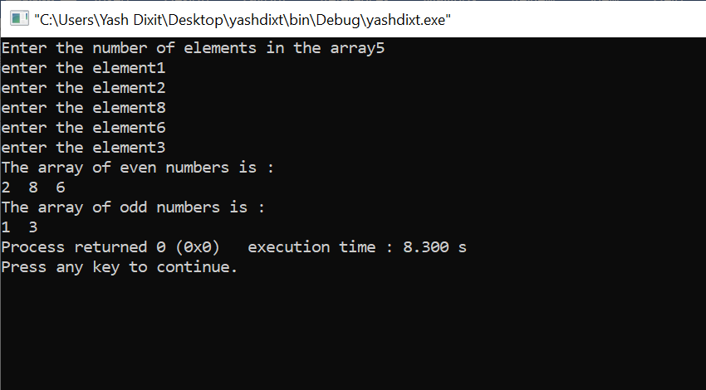

Q7

#include <stdio.h>

#include <stdlib.h>

int main()

{

int n,i,p,k,j;

printf("Enter the total number of the elements in the array:");

scanf("%d",&n);

int array[n];

for(i=0;i<n;i++)

{

printf("Enter th element:");

scanf("%d",&array[i]);

}

printf("Enter the position of the element you want to delete: ");

scanf("%d",&p);

for(j=p;j<n-1;j++)

{

array[j]=array[j+1];

}

for(k=0;k<n-1;k++)

{

printf("%d ",array[k]);

}

return 0;

}

